3大题

实验内容：

必做，以下三题任选，但必须完成一题。

* 将第二章实训题的第二题，登录页面，提交用户名、密码，若用户名不为空字符串且长度在6-8位间，密码不为，空长度为6位，则登录成功，显示“***（用户名）登录成功！”，否则显示“***登录失败”。
* 猜数页面，猜错猜对及输入不正确的情况分别处理，后台随机生成一个0-100的数，让用户猜。最多猜五次，每次猜完后要对用户提示“猜大了”或“猜小了”，如果相等，提示“猜对了，游戏结束！”
* 上一周做的注册页面也可，验证条件可以自行设定，注册之后根据用户输入情况进行相应的提示。

选第三题

设定条件为密码和账号不能为空，若为空则显示注册失败并提示，若不为空则注册成功

<%@ page contentType=*"text/html;charset=utf-8"* %>

<%response.setCharacterEncoding("utf-8");

response.setHeader("iso-8859-1","utf-8");

request.setCharacterEncoding("utf-8");

String name = request.getParameter("name");

String psd = request.getParameter("password");

**if**(name.equals("")||psd.equals("")){

response.setHeader("Refresh","1;url=fail.jsp");

**return**;

}

**else**{

String acc=request.getParameter("account");

String yourName=request.getParameter("name");

out.println("<HTML><BODY><Font size=8><P>注册成功！你的邮箱账号为");

out.println(acc);

out.println("</P><BR>SUCCESS</BR></FONT></BODY></HTML>");

}

%>

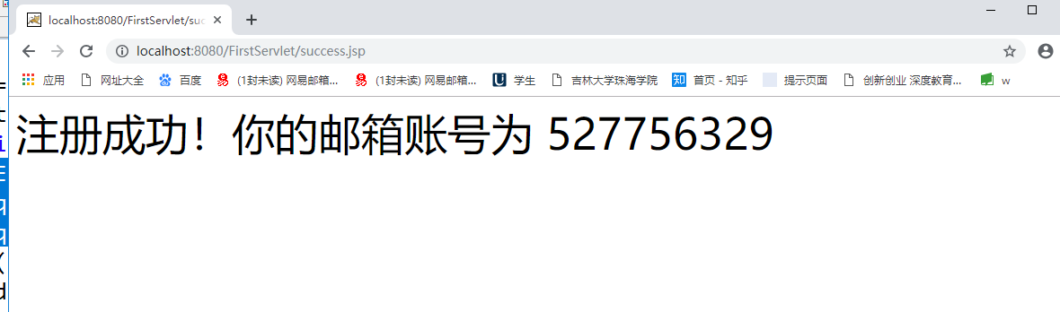

<%@ page contentType=*"text/html;charset=utf-8"* %>

<%response.setCharacterEncoding("utf-8");

response.setHeader("iso-8859-1","utf-8");

request.setCharacterEncoding("utf-8");

String name = request.getParameter("name");

String psd = request.getParameter("password");

**if**(name.equals("")||psd.equals("")){

response.setHeader("Refresh","1;url=fail.jsp");

**return**;

}

**else**{

String acc=request.getParameter("account");

String yourName=request.getParameter("name");

out.println("<HTML><BODY><Font size=8><P>注册成功！你的邮箱账号为");

out.println(acc);

out.println("</P><BR></BR></FONT></BODY></HTML>");

}

%>

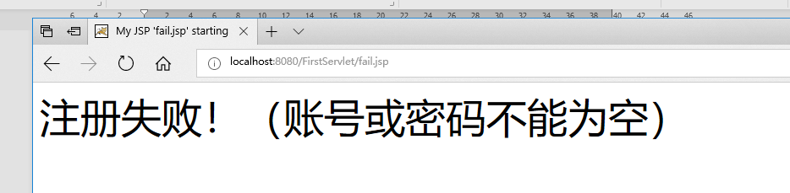

<%@ page language=*"java"* import=*"java.util.*"* pageEncoding=*"utf-8"*%>

<%

String path = request.getContextPath();

String basePath = request.getScheme()+"://"+request.getServerName()+":"+request.getServerPort()+path+"/";

%>

<!DOCTYPE HTML PUBLIC "-//W3C//DTD HTML 4.01 Transitional//EN">

<html>

<head>

<base href=*"*<%=basePath%>*"*>

<title>My JSP 'fail.jsp' starting page</title>

<meta http-equiv=*"pragma"* content=*"no-cache"*>

<meta http-equiv=*"cache-control"* content=*"no-cache"*>

<meta http-equiv=*"expires"* content=*"0"*>

<meta http-equiv=*"keywords"* content=*"keyword1,keyword2,keyword3"*>

<meta http-equiv=*"description"* content=*"This is my page"*>

<!--

<link rel="stylesheet" type="text/css" href="styles.css">

-->

</head>

<body>

<Font size=*8*><P>注册失败！（账号或密码不能为空）</P>

<BR></BR></FONT></BODY></HTML><br>

</body>

</html>